REPORTS – SUMMARIES

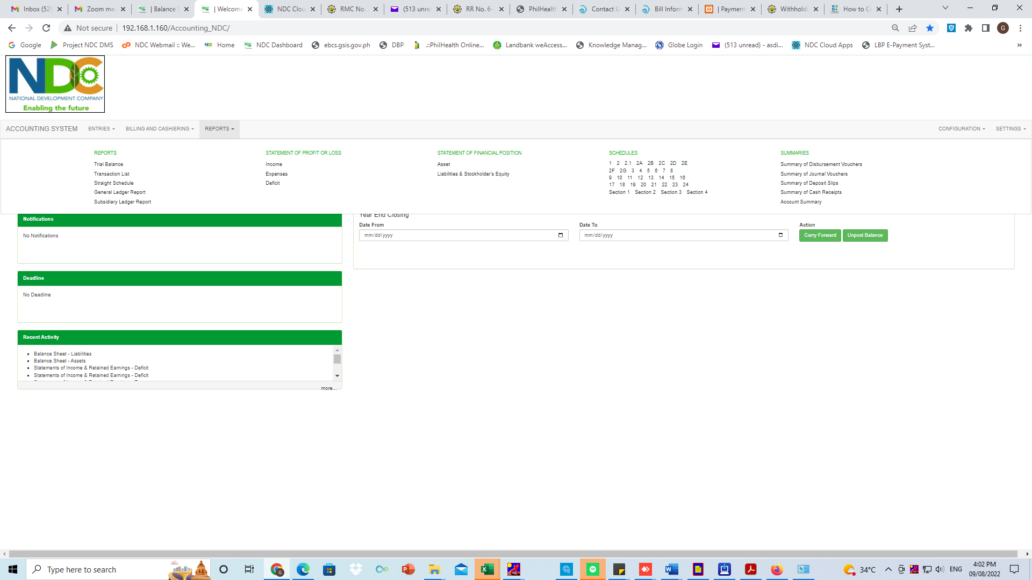

SUMMARIES

* SUMMARY OF DISBURSEMENT VOUCHERS

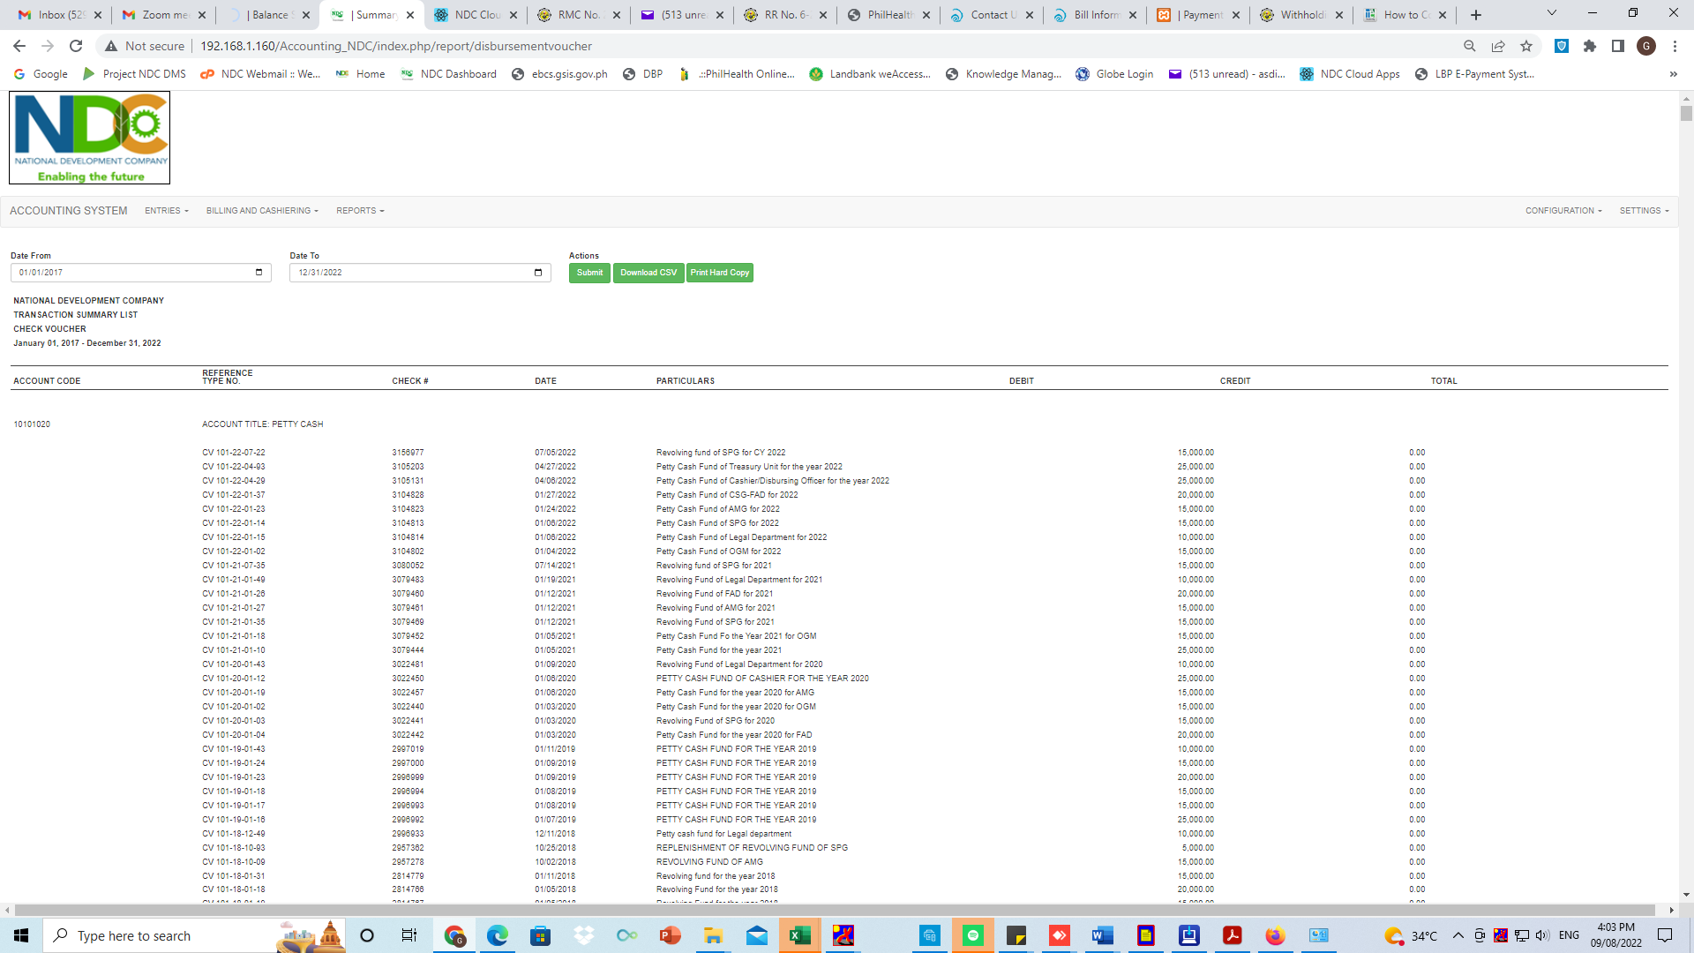

SUMMARIES

* SUMMARY OF JOURNAL VOUCHERS

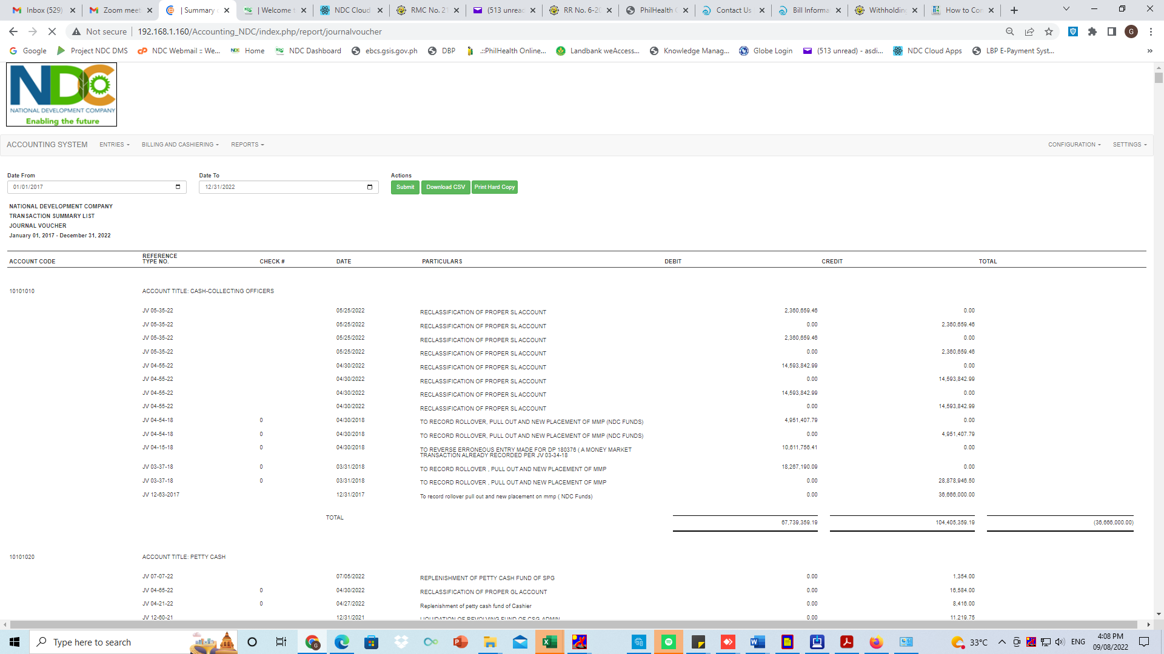

SUMMARIES

* SUMMARY OF DEPOSIT SLIPS

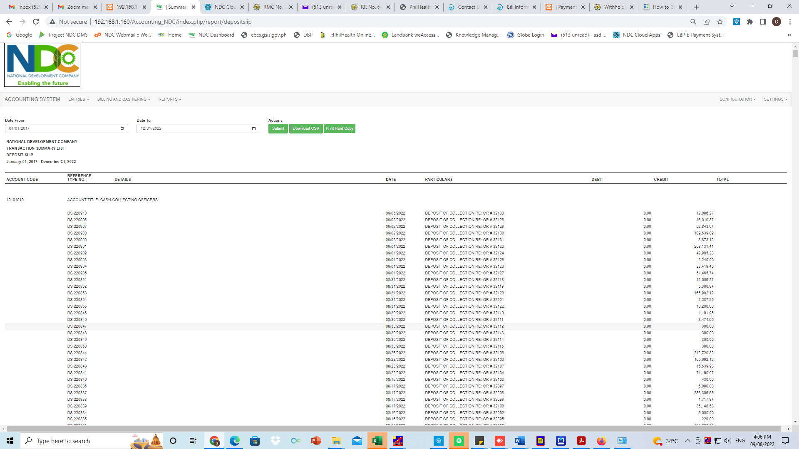

SUMMARIES

* SUMMARY OF CASH RECEIPTS

